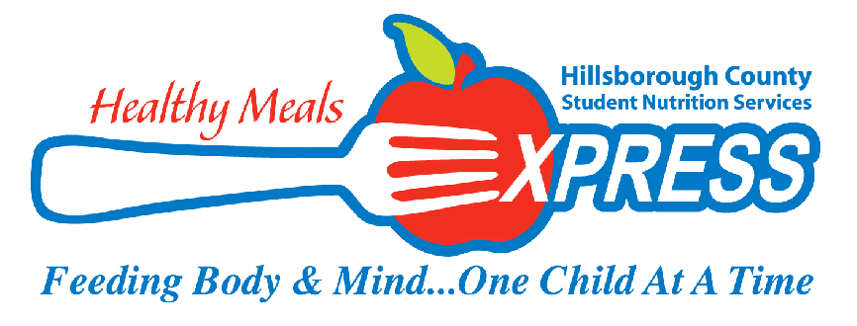
JANUARY 2021 MENU
4  BREAKFAST  Assorted Cereal with Goldfish Graham  Apple Crisp Bites  Low Fat Milk  LUNCH  Kickin Chicken Macaroni and Cheese  Seasoned Black Beans  Peach Fruit Cup  Assorted Low Fat Milk | 5  BREAKFAST  Eggo Mini Waffles With Syrup  or  Apple Cinnamon Craisin Bar  100% Juice  Assorted Low Fat Milk  LUNCH  Cuban Sandwich  Apple Sauce  Tropical Juice Box  Assorted Low Fat Milk | BREAKFAST  Assorted Cereal with Goldfish Graham  100% Juice  Assorted Low Fat Milk  LUNCH  Popcorn Chicken Chunks  Baby Carrots w/Lite Ranch Dip  Fruited Gelatin  Cheez It Crackers  Assorted Low Fat Milk | 7  BREAKFAST  Banana Chocolate Chunk  Protein Bar  100% Juice  Assorted Low Fat Milk  LUNCH  Turkey and Swiss Croissant  Cucumber Slices w/Lite Ranch Dip  100% Fruit Juice  Assorted Low Fat Milk | 8  BREAKFAST  Danimals Yogurt  w/Cinnamon Goldfish Graham  100% Juice  Assorted Low Fat Milk  LUNCH  Sloppy Joe Sandwich  Cauliflower w/Lite Ranch Dip  Fresh Apple Slices  Assorted Low Fat Milk
11  BREAKFAST  Eggo Mini Waffles w/syrup  100% Juice  Assorted Low Fat Milk  LUNCH  BBQ Rub Roasted Chicken  Donut Holes  Honey Glazed Carrots  Peach Fruit Cup  Assorted Low Fat Milk | 12  BREAKFAST  Assorted Cereal w/ Cinnamon Goldfish Graham Cracker  100% Juice  Assorted Low Fat Milk  LUNCH  Italian Deli Sub  Sliced Cucumbers w/Lite Ranch Dip  100% Fruit Juice  Assorted Low Fat Milk | 13  BREAKFAST  Mini Blueberry Pancakes  w/Syrup  100% Juice  Assorted Low Fat Milk  LUNCH  Southern Style Chicken Bites  BBQ Baked Beans  Applesauce  Cheez-It Crackers  Assorted Low Fat Milk | 14  BREAKFAST  Banana Chocolate Chunk Protein Bar  100% Juice  Assorted Low Fat Milk  LUNCH  Bacon Burger Mac n Cheese  Steamed Broccoli  Raisins  Assorted Low Fat Milk | 15  Non-Student Day
18  Non-Student Day  MLK Jr Day   | 19  BREAKFAST  Eggo Mini Waffles With Syrup  100% Fruit Juice  Assorted Low Fat Milk  LUNCH  Cuban Sandwich  Apple Sauce  Tropical Juice Box  Assorted Low Fat Milk | 20  BREAKFAST  Apple Cinnamon Chewy Bar  100% Juice  Assorted Low Fat Milk  LUNCH  Popcorn Chicken Chunks  Baby Carrots w/Lite Ranch Dip  Fruited Gelatin  Cheez It Crackers  Assorted Low Fat Milk | 21  BREAKFAST  Assorted Cereal w/Cinnamon Graham Goldfish Cracker  100% Juice  Assorted Low Fat Milk  LUNCH  Turkey and Swiss Croissant  Cucumber Slices w/Lite Ranch Dip  100% Fruit Juice  Assorted Low Fat Milk | 22  BREAKFAST  Danimals Yogurt  w/Cinnamon Goldfish Graham  100% Juice  Assorted Low Fat Milk  LUNCH  Sloppy Joe Sandwich  Seasoned Peas and Carrots  Fresh Apple Slices
25  BREAKFAST  Eggo Mini Waffles w/Syrup  100% Juice  Assorted Low Fat Milk  LUNCH  BBQ Rub Roasted Chicken  Donut Holes  Honey Glazed Carrots  Peach Fruit Cup  Assorted Low Fat Milk | 26  BREAKFAST  Assorted Cereal w/ Cinnamon Goldfish Graham Cracker  100% Juice  Assorted Low Fat Milk  LUNCH  Italian Deli Sub  Sliced Cucumbers w/Lite Ranch Dip  100% Fruit Juice  Assorted Low Fat Milk | 27  BREAKFAST  Apple Cinnamon Chewy Bar  100% Juice  Assorted Low Fat Milk  LUNCH  Southern Style Chicken Bites  BBQ Baked Beans  Applesauce  Cheez It Crackers  Assorted Low Fat Milk | 28  BREAKFAST  Mini Blueberry Pancakes w/syrup  100% Juice  Assorted Low Fat Milk  LUNCH  Buffalo Chicken Mac n Cheese  Herbed Green Beans  Raisins  Assorted Low Fat Milk | 29  BREAKFAST  Danimals Yogurt  w/Cinnamon Goldfish Graham  100% Juice  Assorted Low Fat Milk  LUNCH  Turkey and Swiss Croissant  Fresh Apple Slices  Tropical Juice Box  Assorted Low Fat Milk

